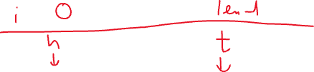

[1, 2, 3, 4, 5, 4, 3, 2, 1]

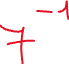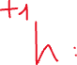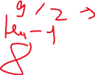

1 2 2 2 3 3 4 5 6



HashMap: data structure using the key-value pairs.



{



1



}